How to Make Horse Hair Helm Padding

Being a compilation of various sources, by Marguerite du Royon.
Source material by Yseult Summerhall, Robert of Woodsende,
Elspeth the Seamstress of Dunkeld, and Brion Thornbird.

Background - Period Helm Padding: In period, the making of helmet liners was apparently the task of skilled laborers, as is evidenced by the mention of one “Nicholas Brampton, a stuffer of bacynets” among the retinue of Henry V at Agincourt. In 1369, there is a reference to the stuffing for a bascinet costing almost half as much as the helmet itself.

Extant Examples
  - Churburg bascinet type (14th Century)

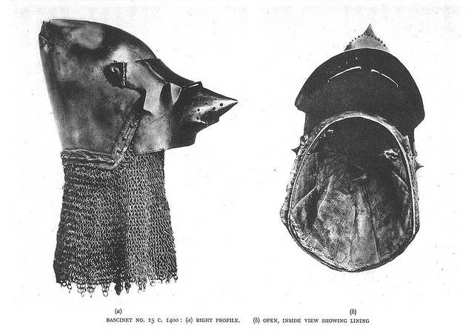

  - Vienna jousting helmet liners (15th Century)
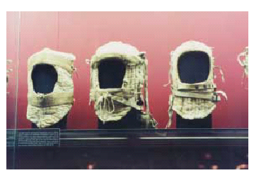
Our experiences so far indicate the following advantages and disadvantages of each of the materials:

Fabrics Used for Liner in Period

- Linen. Advantages: wicks sweat, strong fibers; Disadvantages: wrinkles, hard to find the good stuff, hard to bleach, expensive, wear marks from dryer

- Wool. Advantages: wicks sweat; dries faster than linen or cotton, warm when cool, cool when warm; Disadvantages: expensive, allergies, bugs

- Hemp. Advantages: Very strong; Disadvantages: without modern processing it is very rough, wears to a shiny surface, can get wear marks from dryer

- Silk. Advantages: strong, fine weave; Disadvantages: can be expensive, arguments about use of raw silk in period, rots easily

- Cotton. Advantages: cheap, breathes, was available in period; Disadvantages: holds sweat, was expensive in period, gives the wrong look

Materials Used for Stuffing in Period

          - Horsehair - (body hair and mane & tail hair). Advantages: Harder to obtain and clean initially (easier to get in late fall when horse owners clip their horses), Maintains springiness longer after stuffed (one of Robert and Yseult’s was still going strong after 5 years heavy use), dries relatively quickly after washing; Disadvantages: Requires cleaning and preparation, messy to work with, may have allergy issues

- Fabric/Linen scraps - Advantages: Easy to obtain, no pre-washing, wicks sweat, inexpensive, not as messy to work with; Disadvantages: may be bulky/uneven after stuffing, tends to be firmer and not give as much cushion.

          - Tow - (unwoven fibers of hemp or flax/linen). Advantages: Easy to obtain (try hemptraders.com), doesn’t need to be pre-washed; Disadvantages: Not as springy, longer drying time, somewhat messy to work with. Packs down with use/washing (Robert of Woodsende experimented with tow; but after one washing the tow lining had packed down so much it was no longer usable).

Also used in period but not experimented with:

- Straw – NOT RECCOMMENDED, but used as cheap stuffing in period for helms.

- Oakum, or rope leavings – most likely hemp (see sample of hemp sisal). Used in the Vienna helm liners from 15th century. Advantages: strong fibers; Disadvantages: harder to find, may be too coarse

What you’ll need to build your helm padding:

- Pre-punched helmet. (Note: This is the attachment method for late 14th to early 15th century bascinets. Other helmets may have differing methods – check with an armorer and/or experienced Marshal if you aren’t certain of what is best for your helm.) The helmet should have 3/32 inch holes about 3/8 inch I from the edge of the helmet, to sew the finished padding in place. These should be spaced 3/8 to 1/2 inch apart. Padding should not move at all when you put the helmet on or take it off, thus the liner must be well secured to the helm.

- Paper and Fabric. You will need enough paper to cover the outside of your helm (so you have a pattern in the future), approximately 2 yards of patterning fabric (cheap cotton muslin works nicely) and 1 yard of PREWASHED helm liner fabric (such as linen or wool). Heavy, undyed, tightly woven fabric is best. When choosing your liner fabric you want a densely woven material to minimize the chances that your stuffing material will work its way out and so that it will hold up to heavy use. If you choose dyed fabric make sure the color doesn't bleed. PRE-WASH and DRY your liner fabric!!

- Stuffing. Amount of horse hair needed will vary, but a half full paper grocery bag should be ample for padding one helm. If you run short, contact the West Kingdom EQ Officer (contact info in the Page) to get in touch with a horse owner for more hair. Different people pad their helms differently: some have used strictly horse body hair, and others have used body hair wrapped in coarser mane and /or tail hair. Padding with 100% body hair tends to pack down over time but fluffs up again after washing, while using 100% mane/tail hair tends to be a bit stiff. The mane wrapped body hair may provide added springiness, and be a good compromise between springiness & softness- but body hair alone is pretty springy too. Either method works well, and both allow you to customize the fit by increasing or decreasing the amount of material. Since very few horse owners shave their horses’ manes or tails, mane/tail hair was not provided in the grocery bag, but if you are interested in this method it can be purchased commercially. One source is hitchingpostsupply.com; they have a pound of it for $12 (and a pound is more than enough).

- Cording. Used for closing the top of the padding and (in some helm styles) adjusting the suspension system in the top of the padding. Any sturdy lacing material that does not stretch will work, such as lucet cord, fingerloop braid, or even a short shoe lace or piece of grosgrain ribbon.

- Needle and safety pins (needle nose pliers & thimbles are useful too). A needle with a large eye, such as an upholstery or leather needle, will be needed to thread the cord through the top of the helm padding and to sew the liner to the helm. Your needle will need to be able to pass through the holes in the helm and be strong enough to go through several layers of fabric (hence the use for the pliers and thimble). Safety pins are convenient for temporarily closing the bottom of the horse hair stuffed channels.

- Thread. A light linen (or polyester) thread will be needed to stitch the liner together and quilt channels into it. A heavy waxed linen/leather (or upholstery/carpet) thread will be used to stitch the liner to the helmet. Waxed leather-working thread works very well, and holds up to cleaning & polishing of the helm with a buffer.

- Sewing machine or avid hand sewer.

- 2 old towels (that you don’t mind getting dirty/horse hairy)

- 2 old pillowcases (that you don’t mind getting dirty/horse hairy)

- Sink, strainer/colander (that you don’t mind getting dirty/horse hairy), and shampoo to clean the hair

- Duct tape (a must for any SCA project)

Tine Required: Approximately 12 hours to go from a pile of dirty horse hair to a period helmet liner.

Step 1: Preparing the horse hair.

Horses were raised in a barn, and their hair will need to be cleaned prior to use. First, remove large pieces of excess straw and dirt from the hair. Fill a colander loosely with horse hair, and wet/submerge in hot water about half way up the colander (so the hair doesn’t float out). Wash thoroughly with a silver dollar sized dollop of shampoo, and rinse (see Figures 1 and 2). Repeat the rinse, and if necessary the wash, but we found the hair was reasonably clean after the second rinse.

Fluff up the hair, then squeeze it as dry as possible by hand and place it in an old pillowcase. The entire washing process will need to be repeated 3-4 times to do a grocery bag full of hair (one helm’s worth) in a normal sized colander.

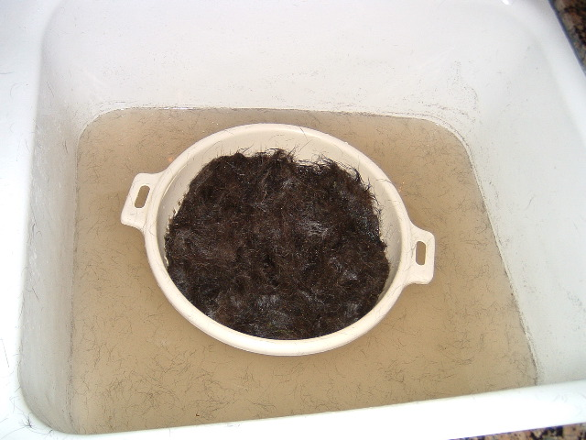
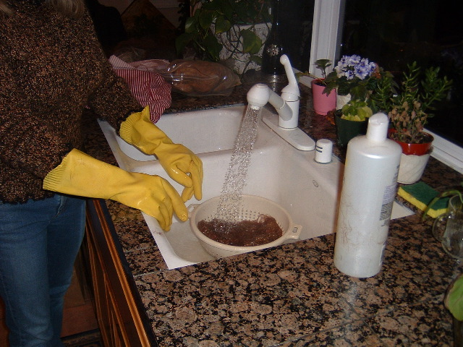

Figures 1 and 2: Washing the horse hair with shampoo in a colander.

Once all of the horse hair is clean, tie the pillow case in a knot place it on the floor between two old towels. Stamp on the towels, pillowcase, and hair to squeeze out all of the moisture that you can (see Figure 3). Dry the horse hair in the sun if weather permits, placing it where it is sheltered from any wind.
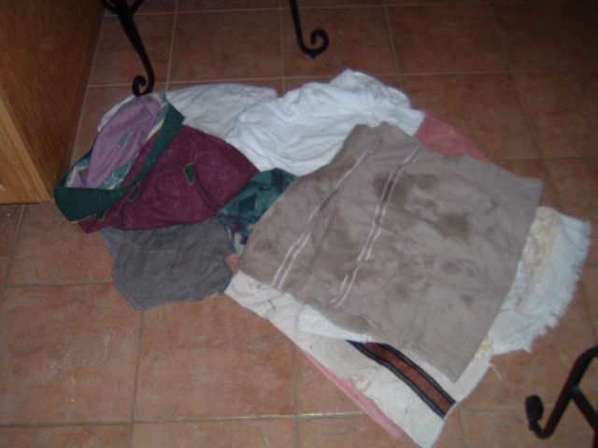
Figure 3: Stamping excess water out of the hair.

If you need to machine dry the hair, place the pillow case full of hair into a second pillowcase, and tie this in a knot also (double casing it will help prevent hair from escaping into your dryer). Place in the dryer on gentle cycle until dry. Different batches of horse hair react differently to drying, depending on the hair texture and the dryer used. Several of the batches we used formed into dense balls/pats of hair during drying, that required separation afterwards into loose hair prior to stuffing (to ensure an even padding with no lumps).

Step 2: Making the Pattern.

A pattern is first made from scrap material to fit the shape of the helmet (this can be done on the inside or outside of the helmet). A quick pattern can be made by taping fabric around the outside of the helm, and then cutting away the excess fabric around the face and bottom. Draw a 3 inch diameter hole where the point/top of the helm is (see Figure 4).

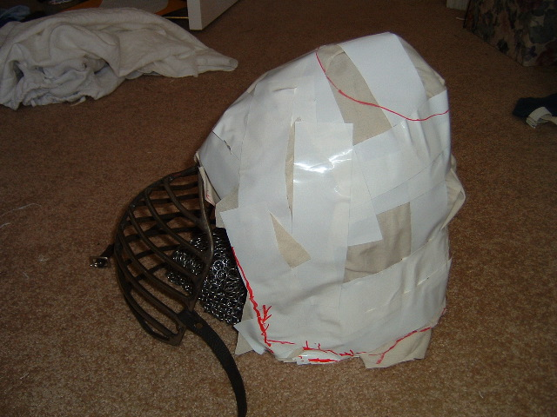
Figure 4: Patterning over the helm.

If you have a weld line or other landmark (such as a vervelle, lacing hole, rivet, etc.) at the center front and center back of the helm mark these on your pattern. Also mark on your pattern the placement and width of chin straps. Cut a 2 inch diameter hole inside the 3 inch circle you have drawn at the top/point of the helm.

Next cut the pattern up the center front to the hole at the top, open and lay flat. Cut a scalloped hole where you drew the top circle in. The tabs/scallops should be relatively shallow, and should be rounded into the top hole as shown in Figure 5. (These tabs will have a cord run through them to create a suspension system in the liner. This applies for any helm shape, but is especially true for bascinets because they taper to a point above the crown).

For the chin strap, you will need to either 1) draw a line radiating downward and cut to allow the chin strap accessed or 2) cut a hole and stitch a large button hole at the point of the strap to pass it through the liner (encircle the hole with strong thread using a button hole stitch). If you use a buttonhole, be sure to place a channel seam there, because it is easier to put the holes for the straps through a line of stitching than through the middle of the padding.

Pencil in lines radiating from top to bottom for the channels. The top of the channels should each be about three quarters of an inch wide, and the bottom about two inches wide to allow for easy stuffing. Channels should be evenly spaced. (See Figure 5).

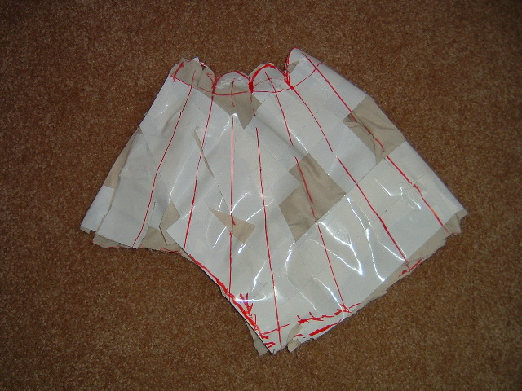
Figure 5: Helmet lining pattern folded in half, with channels drawn onto pattern. Note the top hole is cut in a scalloped shape, and marks for the chin strap still need to be added.

Trace your helm shaped, taped pattern onto a larger piece of pattern paper. Decide if you will place the seam(s) of your liner at the center front, center back, or both (we use center front in this handout). A 1/2 inch seam allowance will work well for this seam and for the seam along the top edge (where you've made your tabs). Be sure to add extra allowance around the sides of this pattern for stuffing (as the liner is stuffed, its dimensions get smaller). I typically add 2 inches to each side to account for stuffing shrinkage. For the bottom edge that will be sewn to the helm, allow yourself at least one inch to finish the edges and seam the two pieces together. Draw all of these seam allowances on to your pattern paper, and transfer the markings for channels, center back, center front, and chin strap access to the paper.
Step 3: Fitting the Fabric Pattern.

Next, lay out your paper pattern on your patterning fabric (cheap muslin) and cut two pieces. Transfer the markings for channels, center back, center front, and chin strap access to your patterning fabric (See Figure 6).

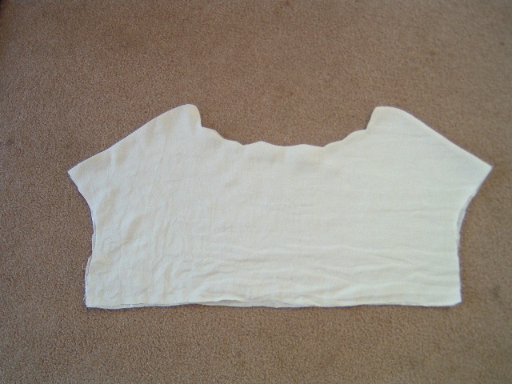
Figure 6: Pattern cut out of cheap muslin for final fitting.

Then sew the two pattern pieces together along the top edge, leaving the face opening and bottom edge open (to allow for stuffing), and turn them right side out so that the seams are on the inside. (Note: On the FINAL helm padding (not on the pattern), you will need to finish the edges that will be sewn to the helm around the bottom and face opening, by turning a 1/2 inch hem to the wrong side of the fabric and sewing between the edge and the fold). Stitch in the channels’ radiating quilting lines and cut the slits for your straps (Note: On the FINAL helm padding (not on the pattern), you will need to finish the edges of the cuts or do buttonholes).

Stuff the pattern tightly with cloth or newspaper (See Figure 7) and safety pin the bottom edges. Sew up the center front/center back seam(s), and try it on with your helmet to finalize the fit. It should be snug inside of the helmet and fit your head very close, but not be uncomfortable.

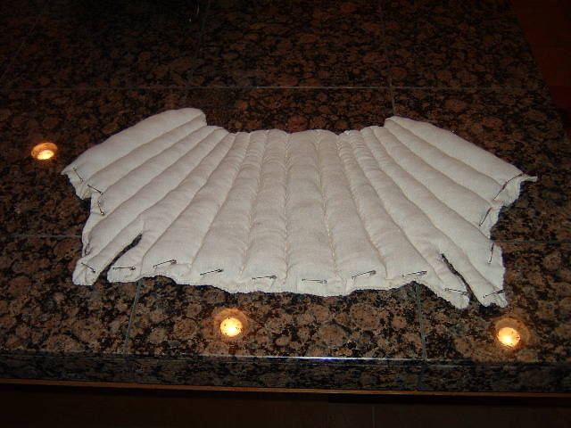
Figure 7: Pattern stuffed and safety pinned for final fitting.
The liner may look too small. Usually this is an illusion. If it should actually be too small, this can be remedied by simply adding another stuffed channel of appropriate size. Once you are satisfied, remove the mock up from the helmet, discard the stuffing materials, and use this as a pattern. Cut the final liner out of the tightly woven fabric you selected (linen or wool preferably) Sew together exactly as described above for the mockup.

Step 4: Stuffing and finishing your Liner

After all your channels are stitched, the edges are finished, and you've made the holes for straps to be passed through, it's time to stuff the liner. When stuffing the horsehair, form the loose body hair into a small ball that will easily fit into your channel (you may wrap the ball of body hair in mane/tail hair if you wish). Stuff it in using any implement that won’t catch on your fabric (chopsticks, wooden spoons, and wood dowels all work well).

Begin by padding out the top tabs and adding a drawstring. The drawstring allows some adjustment of how the liner fits. This also allows the liner to serve as the suspension for the helm.
There are two ways of doing this, and it is strictly a matter of personal preference – either:

- Eyelets can be made through the fabric and button hole stitched (if you are using a shoelace or other cord too thick to pass through the eye of a needle you will probably save yourself a headache later by sewing the eyelets). For this method, put a small amount of padding into the tip of each tab and then sew eyelet holes to pass your cording through. Metal grommets are not recommended, however, since the tabs will be sitting on the top of your head and bearing the weight of your helm and camail or aventail if you wear one.

- Since the tabs don't require a large amount of padding you may decide to just skip the eyelets and thread the cord through with a needle – this works great for most cords. An upholstery needle can be used to work a thin, but strong, multi-ply cord through the fabric about one or two inches down from the top.

Pack the hair into all of the channels firmly, and temporarily close them using safety pins. This is quite a time consuming process, and will use an amazing amount of horsehair. You may find that you need to add or remove padding in some areas to achieve a comfortable fit. Once the whole unit is assembled you will be able to make adjustments in how closely or loosely the tabs are tied together to adjust how the helm sits on your head. Thread your chin straps through the openings you stitched in the liner, and try it on.

When you are satisfied with the fit and feel of the liner, sew/whip stitch the open edges closed just above the hem you stitched earlier. Turn up another 1/2 inch hem, turning both edges to where the seam will sit between the liner and helm, then stitch this closed (see Figure 8).

So far the liners that are in use have worked fine for several years without additional horse hair. The one pictured in Figure 8 was fine for 5 years of fighting, and is still in good shape! But you may want to save any extra horse hair that you have, as over time and with washing you might need to add extra hair eventually (Note: This would require you to remove the liner from the helmet, carefully rip open the bottom seam with a seam ripper, and insert more horse hair into the channels. You would then need to re-sew the bottom seam and reattach the liner to the helmet.)
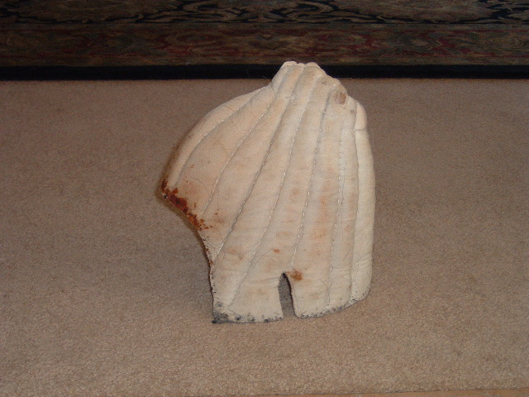
Figure 8: Completed horsehair helm lining, with chin strap slit and top suspension cording visible.

Step 5: Attaching the liner to the helm

The helmet should have 3/32 inch holes about 3/8 inch I from the edge of the helmet. These should be spaced 3/8 to 1/2 inch apart. (Note: This is the attachment method for late 14th to early 15th century bascinets. Other helmets may have differing methods – check with an armorer and/or experienced Marshal if you aren’t certain of what is best for your helm.)

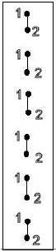

The finished liner is then sewn to the helmet using the waxed linen/leather heavy duty thread, and using a running stitch. Sew the helm padding to the helm using the marks you made to help line up the center front and center back. You may want to experiment to find the stitching method that works best for you. To do a running stitch, go up through one hole and down through the next, repeating the process until you are back to where you started. At this point reverse directions, going back the other direction so that your stitches are the opposite of your earlier stitches. (Refer to the Stitching Diagram at left - Bring your needle up through hole 1 and down through hole 2, repeating until you are back to where you started. Then bring your needle up through hole 2 and down through hole 1, repeating until you have stitched all the way around again.)

The finished helm padding is ready to be fought in, and should last several years! Figure 9 shows the completed helm padding attached under an aventail.

The liner will be very tight the first time it is worn, but will pack down and shape to your head over time. Also, in one instance the use of a helmet stand caused the padding to distort and gave the wearer headaches, so if your helm is heavy you may not want to place it on a stand (the headaches went away after the stand was discarded and the padding re-formed to the head).

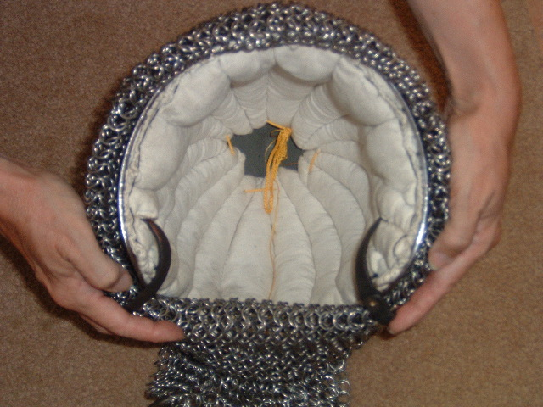
Figure 9: Completed horse hair helm padding, sewn into a bascinet under an aventail.

Maintenance: Care and feeding of the horse hair helm padding
When the waxed linen thread breaks down, it is a good time to take the liner out and wash it (preferably by hand).

To hand wash: (Be sure to allow enough drying time- it can take several days to air dry). Wash the helm padding in warm water with shampoo or laundry soap. Rinse thoroughly, then wrap it in a towel and squeeze out excess water to hasten the drying process. Set it out in the sun to air dry and placing it on a towel in an upright position to help drain and draw the moisture out. On cold, inclement days fireplaces also work well for drying and they have the added advantage of being period. After it has dried, and checked for excessive wear, it can be re-sewn back into the helmet.

If you must use the washing machine/dryer: Use the most gentle cycle available otherwise the agitator in your machine will really beat up your liner and may cause the padding material to mat and clump (resulting in uncomfortable lumps). Place the liner inside an old pillow case and tie the pillow case shut securely around the helm padding. Place this pillow case inside a zippered laundry bag or a second pillow case also tied securely around the padding. These two steps should help keep the padding in the pillow case and minimize the stuffing material escaping into your machines. When drying your liner use your machine's shoe rack if you have one. If you don't have a shoe rack or shelf for your dryer, consider buying a bag such as the "Sneaker Dryer" that hangs on your dryer's door. These are available in catalogs and will help prevent unnecessary pounding on your helm liner (and perhaps extend its life span).

Special Thanks to:
Debora Saint James aka: Viscountess Yseult Summerhall and Robert Holland aka: Viscount Sir Robert of Woodsende - who provided all of the know how on this helmet padding, but have quietly remained behind the scenes; Carol Newby aka: Elspeth the Semstress of Dunkeld, OP, for allowing me to extensively copy her paper in this handout; and Earl Brion Thornbird ap Rhys (Brian Price) for publishing his excellent book.

Bibliography:
Reproducing 14th Century Helm Padding by Carol Newby aka: Elspeth the Semstress of Dunkeld, OP Available on line at: www.neei.com/~ladybug/

Debora Saint James and Robert Holland. (Viscountess Yseult of Summerhall and Viscount Sir Robert of Woodsende) Class notes, “Toward a More Authentic Field Appearance.” West Kingdom Arts and Sciences Class, A.S. XXXIX (2004).

Price, Brian R. Techniques of Medieval Armour Reproduction, The 14th Century.
Boulder, CO: Paladin Press, 2000.

Strapping Helms in a Historical Manner, a paper by D. A. Biggs (Available on line)

